Annual Assessment Report for 2020-2021 AY
Reports completed on assessment activities carried out during the 2020-2021 AY will be due September 30th 2021 and must be e-mailed to the Director of Assessment, Dr. Douglas Fraleigh (douglasf@csufresno.edu).
Provide detailed responses for each of the following questions within this word document. Please do NOT insert an index or add formatting. For purposes of this report, you should only report on two or three student learning outcomes (department’s choice) even if your external accreditor requires you to evaluate four or more outcomes each year. Also be sure to explain or omit specialized or discipline-specific terms.
Department/Program: Educational Leadership Department/Educational Leadership and Administration Option and Preliminary Administrative Services Credential Degree: MA
Assessment Coordinator: Jessica Hannigan
- Please list the learning outcomes you assessed this year.
SLO: Use multiple assessment measures to evaluate student learning and drive an ongoing process of inquiry focused on improving the learning of all students and all subgroups of students.

- What assignment or survey did you use to assess the outcomes and what method (criteria or rubric) did you use to evaluate the assignment? Please describe the assignment and the criteria or rubric used to evaluate the assignment in detail and, if possible, include copies of the assignment and criteria/rubric at the end of this report.
In EAD 274 course, students had to complete a culminating assignment called Initial Data Collection – Investigation Stage. Based on their chosen California state indicator, students had to select and analyze multiple quantitative data sources across three years for a selected school, identify patterns and/or trends related to equity, choose a student group, and cite research to support patterns/trends related to their identified inequity subgroup.

Initial Data Collection – Investigation Stage Rubric

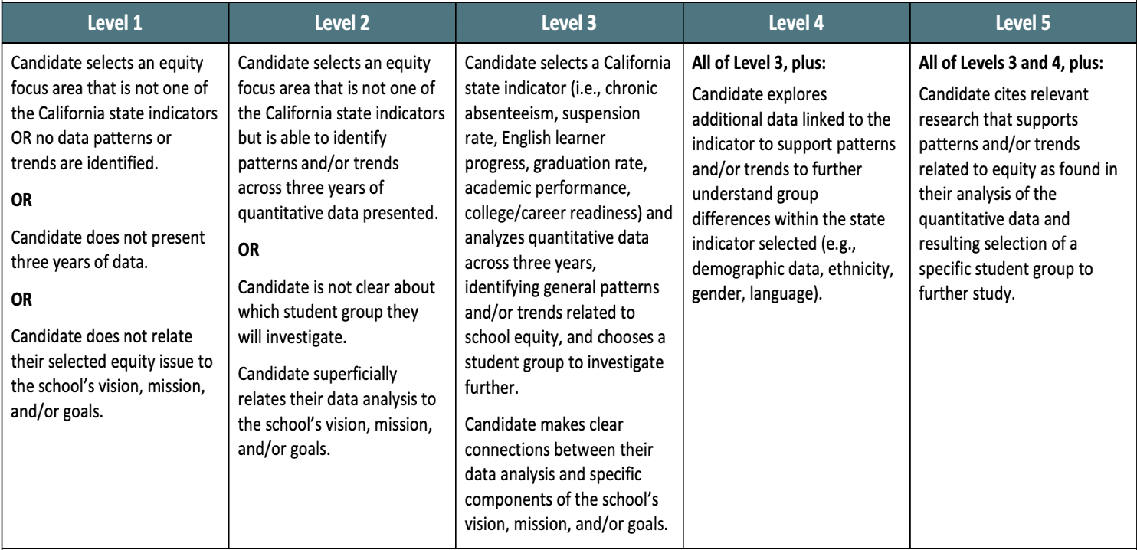

Initial Data Collection – Investigation Rubric Scores 2019-2020
Program Benchmark is Level 3 or higher.

Submission Year 19-20 | Rubric Score Average  Level 1-Level 5 | Benchmark Met 3 or higher
N=27 | Mean Score: 3.0  Level 1- 0  Level 2- 0  Level 3- 27  Level 4-0  Level 5-0 | Yes, 100% met 3 or higher on submissions.  SLO: Benchmark Met

- What did you learn from your analysis of the data? Please include sample size (how many students were evaluated) and indicate how many students (number or percentage instead of a median or mean) were designated as proficient. Also indicate your benchmark (e.g. 80% of students will be designated as proficient or higher) and indicate the number of students who met that benchmark.
Student success was measured at Level 3 or above as proficiency. Overall, 27 out of 27 (100%) of the students performed at the rubric proficiency expectation based on the 2019-2020 assignment rubric data. Student evidence shows that they are able to collect data and identify patterns or gaps that highlight student inequities. We found based on our analysis of this data set, our instruction was geared toward the students meeting a level 3. We had a discussion as a program about how we were going to put some practices into place to help our students attain level 4 and/or level 5s. See next steps outlined in question 4.
- What changes, if any, do you recommend based on the assessment data?
Further instruction on how to triangulate quantitative and qualitative data to demonstrate a sophisticated analysis of equity disparity among groups of students would be a future emphasis and an added layer of support in connecting multiple data findings to relevant research will be a focus to help students meet the level 4 and/or level 5 standards. Specifically, we decided to implement the following two strategies 1) Intentional opportunities for rubric centered peer to peer feedback embedded into the courses and 2) implement a Faculty Learning Community focused on reflection and development of rubric analysis, instructional best practices, and resources/practices/materials for mastery.
- If you recommended any changes in your response to Question 4 in your 2018-19 assessment report, what progress have you made in implementing these changes? If you did not recommend making any changes in last year’s report please write N/A as your answer to this question.
N/A – We have revised our entire program to match the new state level credentialing requirements. We also use to be two programs and so our last SOAP does not reflect our stand-alone program and changes.
- What assessment activities will you be conducting during AY 2021-22?
We are working on updating our SOAP this 2021-2022 school year to match our program redesign and alignment of our program with state and national accreditation standards.
A few assessment activities aligned with state and national accreditation we will be conducting in 2021-2022 include:
P12 PASC Program AAQEP Candidate Self-Assessment. The purpose of this self-assessment is to have students reflect on their perceptions of personal growth in the CAPEs and AAQEP standards over time in the PASC program. The information from this self-assessment is utilized to inform both areas of strength and opportunities for growth for students, as well as inform programmatic and instructional decision-making for ongoing continuous improvement. Each semester students are provided the opportunity to grow professionally as an aspiring equity driven school leader. Based on overall program coursework, activities, readings, and discussions, as well as fieldwork experiences through the CalAPA and other supervised activities with your field mentor supervision. This assessment is designed to help students reflect on a wide range of knowledge and experiences essential to their preparation. This self-assessment is divided into three sections: 1) AAQEP Program Standards Assessment, 2) CTC CAPEs Self-Assessment , and 3) Written Narrative Reflective Response.

CalAPA Assessment Evidence. Candidates in each administrative services credential program in California must demonstrate content and skill knowledge on three performance assessments prior to the attainment of a preliminary credential. Each performance assessment or leadership cycle contains required knowledge and skills found in the California Administrator Performance Expectations (CAPEs). The CalAPA consists of three leadership cycles that focus candidates on specific content knowledge, a different set of skills, and knowledge to demonstrate new learning relevant to school administration. Each cycle includes professional dispositions that school administrators should know and be able to demonstrate. There are 4 steps in each CalAPA performance assessment which include the following actions: Investigate, Plan, Act, Reflect, in a continuous improvement model based on collected data from fieldwork school sites.

Each leadership cycle includes either 7 or 8 analytic rubrics that measures knowledge and skills candidates must evidence in narrative writing, document artifacts, and/or video. Each rubric is aligned to specific CAPEs organized by a scale from Level 1 to Level 5. Based on the overall passage score for each cycle, candidate success or proficiency would be measured at Level 2. As of 2019, each CalAPA leadership cycle has a summative passing score as follows:
- Cycle 1 (8 rubrics): A final cut score of 14 points.
- Cycle 2 (7 rubrics): A final cut score of 12 points.
- Cycle 3 (7 rubrics): A final cut score of 12 points.

- Identify and discuss any major issues identified during your last Program Review and in what ways these issues have or have not been addressed.
We did not have major issues during our last program review. However, since the last review we have become a stand-alone program in our department. We went through the extensive process to meet that goal.

