GE Area A2 Written Communication:
SLO Evaluation Report May 2019

Background/Description of GE Program ePortfolio:
Prior to the 2017-2018 AY, departments/programs were responsible for assessing GE student learning outcomes and submitting a report every year for the GE Committee to review. This system had several weaknesses. Departments and programs were responsible for deciding which of the two to four outcomes designated for a specific GE Area to assess; thus some outcomes were evaluated multiple times within a year and others were not evaluated at all in certain years. It was also not possible for departments to access and evaluate a representative sample of student work, nor was it possible to compare the results from GE courses in the same GE Area taught by different departments/programs, because all departments/programs used their own criteria/rubrics. Finally, the GE Committee was not able to review and analyze the GE assessment reports in a comprehensive fashion, since the committee was also tasked with reviewing all GE curriculum proposals, as well as discussing and updating GE policies and procedures.
Therefore, Fresno State developed and proposed a new system of evaluating GE student learning outcomes during the 2014-2015 AY. The proposal was approved by Fresno State’s Academic Senate in May 2017 and by President Joseph Castro in August of 2017. The new system requires that all freshmen and transfer students admitted to Fresno State beginning in Fall 2018 will submit one designated assignment (papers, exams, videos, lab handouts, etc.) aligned to one GE student outcome from lower-division (for freshmen) and upper-division (for freshmen and transfer students) GE courses to a GE Program ePortfolio via Blackboard. Students will also write 300-word reflections (freshmen write three and transfer students write one) about their learning experience(s) and submit these to the GE Program ePortfolio. The GE Program ePortfolio was set up by the Director of Assessment and students were automatically enrolled. Handouts, videos, and other resources that were posted previously to Blackboard were uploaded to Canvas when the campus transitioned from Blackboard to Canvas in summer 2019.
During the first year of implementation (2017-2018 AY), efforts focused on electing members to the new GE Assessment Subcommittee and on approving common rubrics across GE areas to be used to evaluate GE student learning outcomes. Fresno State’s GE student learning outcomes were approved by the Academic Senate in 2010. These are the forty outcomes that will be evaluated on a five-year schedule. Beginning in the 2018-2019 AY, a team consisting of the Director of Assessment, ten faculty members serving on the GE Assessment Subcommittee, and a student representative appointed by ASI, Inc. (student government) selected a random sample of student submissions for all ten outcomes in GE Areas A1, A2, and A3, then evaluated these submissions to determine proficiency in the GE student learning outcomes for GE Area A.
GE Assessment Subcommittee: Evaluation and Norming Process:
The GE Assessment Subcommittee had previously reviewed and approved common rubrics for evaluating each of the ten GE student learning outcomes designated for GE Area A. The committee also discussed the specific assignments submitted for each outcome and evaluated how well each assignment aligned to a specific GE student learning outcome. Finally, after two committee members were assigned to evaluate specific student learning outcomes, the Director of Assessment held a two-hour meeting with all five faculty teams where the appropriate rubric was used to evaluate sample student work as part of the norming process. Each reviewer scored the student work independently. Clarification was provided as necessary during the period in which the faculty teams were reviewing and scoring the assignments. After scoring the work, faculty teams met to identify common strengths and weaknesses; a third reviewer scored all assignments on which the two reviewers did not agree about proficiency.
Outcomes and measures (assignments) used to evaluate A2 outcomes:
Upon completion of an Area A2 (Written Communication) course, students will be able to:

- Demonstrate appropriate language use, clarity, proficiency in writing, and citation mechanics.

- Demonstrate effective academic reading strategies and processes, as well as critical evaluation of written work.

- Demonstrate effective academic summary, rhetorical awareness and perception, and analysis and synthesis of information.

Assignments:
Professors teaching English 5B and English 10 courses that satisfy the requirements for GE Area A2 assign multiple writing assignments during the semester. In both 5B and in 10, writing is incorporated throughout the semester. Assignments were primarily longer papers due toward the end of the semester. Students taking 5b submitted essays focused on a specific topic and a few of these were shorter papers, while students taking English 10 submitted the final paper, which required a research element and argument. Some sections of English 5B and 10 required students to submit their portfolio, which included several different essays and a reflective essay that focused on what they learned through the writing process. All of the papers submitted and evaluated required an introduction and distinct supporting points, and required references to one or more sources. Writing assignments are standard across the English first year writing courses that count for GE requirements and thus assignments of the same kind were reviewed for all three learning outcomes. The only appreciable difference in submissions from students who had different professors was in the topic of the essays or research papers.
Review Process:

Approximately thirty papers were reviewed for each of the three student learning outcomes for GE Area A2. Each of the papers in the random sample selected was evaluated for only one of the three learning outcomes for GE Area A2. The papers submitted aligned very well with outcome one on basic writing proficiency, as well as with outcome three on rhetorical awareness and perception and analysis and synthesis of information. The papers submitted also aligned with outcome two relatively well. Due to extensive time and coordination of schedules, it was NOT possible to evaluate the outcome through direct observation of the class or of academic reading strategies as applied by students. However, one of the assigned papers in English required students to demonstrate their understanding (which they acquired by applying reading strategies and processes) in order to identify key points from specific articles. Since this assignment required students to apply reading strategies, it was used to evaluate outcome two.
Results for Outcomes A2 outcome 1, A2 outcome 2, A2 outcome 3
All of the rubrics for the GE outcomes for A2 were holistic and therefore consisted of a single criterion with several components. The overall results confirm that students are proficient in basic writing skills, with an average of 94% proficienct across the three outcomes. (See Table 1) For A2 outcome 1, thirty-one student papers were evaluated and 28 (90.3%) were deemed proficient. The comments indicate that most papers make clear statements and have only minor grammatical errors. The comments on the three papers that were deemed not proficient emphasize that sentence meaning is not clear and that sentence structure is problematic. For A2 outcome 2, a total of thirty-six student papers were evaluated and thirty-three (91.7%) were deemed proficient while three (8.3%) were not proficient. The comments note that the students have identified and clearly stated the main arguments and central claims of the text. For A2 outcome 3, a total of thirty-two student papers were evaluated and all thirty-two students (100%) were deemed proficient. The comments emphasize that the students have met the desired outcome.
Table 1. Student Proficiency and Inter-rater Reliability Averages for GE Area A2
 | A2.1 | A2.2 | A2.3 | Overall A2
Student Proficiency | 90.3 | 91.7 | 100.0 | 94.0
Inter-rater  Reliability | 83.8 | 91.7 | 87.5 | 87.7
N | 30 | 35 | 31 | 96

Inter-rater reliability
Fresno State’s benchmark for inter-rater reliability is 90%. This was only met for one of the three outcomes for GE Area A2. The inter-rater reliability was 84% for outcome 1, and 92% for outcome 2, and 88% for outcome 3. The average across the three outcomes was 88%. Since the benchmark was met for one of the three outcomes and almost met for a second outcome, it is clear that the norming process with faculty was relatively successful for GE Area A2. For two of three outcomes, the faculty disagreed about proficiency in only a few cases. Furthermore, the faculty disagreed most about outcome one. Inspection of the evaluations shows that the discrepancies primarily occurred because one faculty member did not deem students proficient unless they had clearly cited multiple sources without making any grammatical mistakes in the citations. This is a slightly stricter interpretation of the outcome than was discussed during the norming session and resulted in a slightly lower inter-rater reliability rater. (Going forward, this can be easily resolved by placing greater emphasis on the actual expectations for citations.) See Figure 1 for student proficiency and inter-rater reliability averages.

Figure 1. Graph of Student Proficiency and Inter-rater Reliability Averages
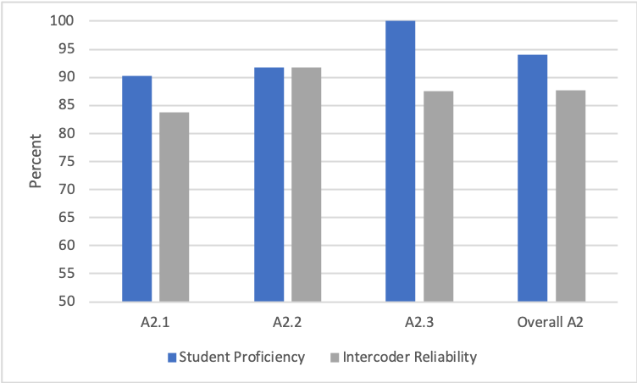

Conclusions
Overall, Fresno State students are proficient in first-year writing skills and basic sentence construction. Furthermore, about a third of students evaluated for outcomes two and three were deemed advanced and all of these students have writing skills that exceeded expectations for written communication skills in first-year courses. For the students who were deemed proficient and not advanced, most of their sentences were clear enough to convey meaning, and wording and grammatical errors were relatively minor. However, it is clear that there are some weaknesses in student writing related to organization of ideas, the ability to incorporate complex sentence structures, and the use of sophisticated and diverse language. These issues might make it more difficult for students to demonstrate advanced writing skills in upper-division courses in certain majors and should be an area of focus going forward.

