THE MINUTES OF THE EXECUTIVE COMMITTEE
OF THE ACADEMIC SENATE
CALIFORNIA STATE UNIVERSITY, FRESNO
Fresno, California 93740-8014 Fax: 278-5745
Telephone: 278-2743 (EC-10)

March 1, 2021

Members present: Thomas Holyoke (Chair), Raymond Hall (Vice Chair), Rebecca Raya-Fernandez (At-Large), Tinneke Van Camp (At-Large), Jennifer Miele (At-Large), Lisa Bryant (Universitywide), Susan Schlievert (Statewide), Saul Jiménez-Sandoval (Interim President), Elizabeth Zuñiga (ASI Executive President)

Members excused:

Guests: Venita Baker (Academic Senate), Xuanning Fu (Interim Provost), David Low (Chair Personnel Committee), Jim Marshall (Dean of Graduate Studies and Special Assistant to the Provost), Marsha Baum (AVP for Faculty Affairs)

The meeting was called to order by Chair Holyoke at 3:00 pm on Zoom.

- Approval of the Agenda.
MSC

- Approval of the Minutes 2.8.21
MSC

- Communications and Announcements.

Interim President Jiménez-Sandoval started with an update on the Mental Health Task Force and told the committee that a video conveying a message from the task force will launch Friday. He mentioned that CARES act funds, upwards of $50M will be distributed to students soon after Spring break. He spoke of the work of the Repopulation Task Force, which is going well, but reminded the committee that all is conditioned on vaccine distribution and whether social distancing will still be needed in the Fall, and that the Provost will launch a survey to the Faculty next week which will assess attitudes about repopulation.

Ms. Zuñiga asked when the Cares Act funds will be distributed. The President indicated after spring break. Ms. Zuñiga then asked if the commencement will be last year’s graduates plus this years. The President answered in the affirmative. Ms. Zuñiga further inquired about the graduation fee, and was it used last year. The President answered that the committee will make clear how fees are used, and what the program will entail. He said he’s not sure but thinks the fee was waived last year. (From later in the Chat: Hi everyone, to the question of last year’s commencement fee, I received confirmation from Dr. Coon that the fee was charged before covid hit, but was refunded consequently. Elizabeth, if there is a question for which you still need an answer, please let me know. Best, Saúl)

Interim Provost Fu gave two updates: 1) Student and faculty surveys will go out soon, and drafts were given to ASI and AS for feedback, and he emphasized the urgency to get this feedback to know what classes will be needed in Fall 2021. 2) We need to get the UG Dean search going before summer, and quick action is needed in making faculty appointments to the Search Committee

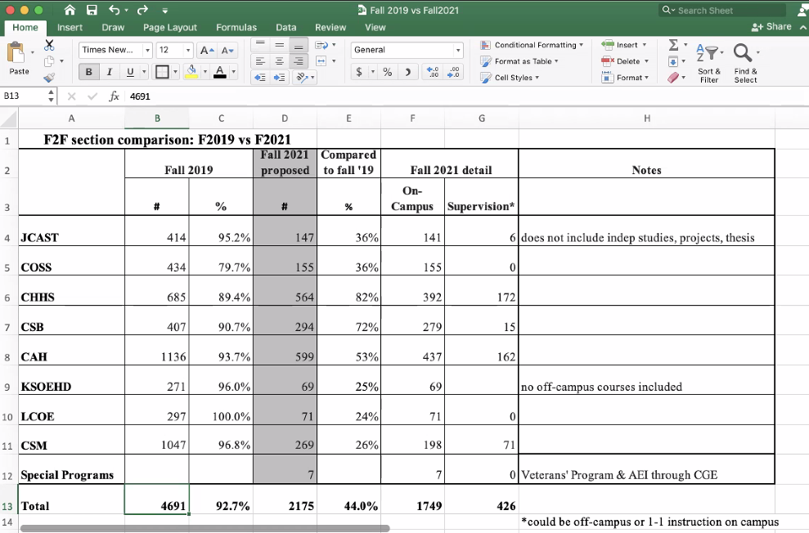

The Provost shared the above spreadsheet, and noted that deans are requesting 44% of courses Face to Face (f2f), although a more likely estimate will be 50%+ wish to be offered f2f (proposed by colleges). This does not however consider social distancing needs (if any) or vaccine distribution.

Dr. Dyer expressed concern that chairs interpreted the request as “what must be taught”, not “what is wished to be taught” when this survey was send from the deans. She feels the numbers would be different if chairs specified “what is wished to be taught” instead. Dr. Marshall indicated that he is sensitive to this as he has heard that some chairs had different interpretations. Dr. Marshall also told the committee that the Deans all were given the same message. Provost Fu explained that for the round 2 survey we will message chairs directly. Dr. Schlievert confirmed from her department that they heard what Dr. Dyer heard in terms of the request to chairs, “must”, not “wished”.

Chair Holyoke explained we will select faculty for Dean’s search committee in executive session today. He asked Provost Fu when feedback on survey is needed. Provost Fu said by midweek would be fine.

Chair Holyoke noted that the Senate agenda is backed up, so we will minimize announcements and focus on policy for next couple meetings.

Action Items

A. Resolution dated February 26, 2021 from the Department of Media, Communications and Journalism re: Faculty Hours. Resolution has been received.

Suggestion: deserves a hearing- send to Personnel Committee.

- Changes to student ratings questions.
Dr. Dyer described aspects of the Student Ratings of Instruction instrument creation, and how it used reliable items from other validated instruments, but made minor adjustment to questions, such as one word changes that would not impact reliability. She described an issue in Kremen, where evaluations of student teaching cannot use current items in the current pool, and how she worked with Kremen faculty to create questions to fit their needs and be added to the pools. She told the committee that the Student Ratings committee had met and agreed that these changes are similar to other changes and that these items could be added without altering reliability and validity.
Dr. Low asked if the changes need to be vetted in terms of CBA compliance. Dr. Baum agrees that correct titles need to be used and that categories are correct. Dr. Holyoke asked if this matter can be handled between Dr. Dyer and Dr. Baum, and both agreed that it could. Dr. Low indicated his support. Dr. Dyer explained that Kremen and other programs were out of compliance, and that these changes to the pool will be a big improvement and bring many courses into compliance with policy. Dr. Baum Zoom-applauded this comment.

- APM 335 - Policy on Periodic Review of Academic Administrators
Dr. Low explained that they were tasked with considering chair evaluation. Upon review the committee proposes a formative assessment in second year (only for first term). Dr. Baum explained that this models the APMs governing assessment of Deans and other leadership roles. Chair Holyoke asked how burdensome this would be on a chair. Dr. Low described how it would provide feedback from the first year experience, and that we are not proposing defined procedures as yet. Dr. Baum said that the model is identical to end of term process, and should not be onerous. Dr. Dyer, in her role as Chair of Chairs, expressed her support for this, and stated that chairs have expressed their desire for earlier evaluations. She told the committee that the Chairs Council would be happy to be involved in deciding what should go into such an evaluation, and that she will arrange to have Dr. Low address the council. Dr. Bryant expressed concern about possible negative impact on small departments where anonymity might be lacking. Dr. Baum described the survey strategy and the supervisor to faculty member interaction, which is done through the Dean. Dr. Miele expressed her support, but added that clarity of process might be useful to include. Dr. Baum mentioned that current procedures vary college by college. Dr. Dyer advocated that the APM should be specific in timeline and responsibility for scheduling. Dr. Miele noted that it’s there in line 4 (colleges create procedure, Dean fulfils).
Place APM 335 on senate agenda:
MSC

- APM 125 - Policy on Department Chairs
Similar to above but for MPPs.
Some minor corrections made (Chair Holyoke will supply).
Place APM 125 on senate agenda:
MSC

- Executive Session.
Enter 4:18pm
Exit 4:21pm
Motion to approve:
Virginia Crisco
Srinivasa Konduru
Kathleen Dyer
MSC
-------------------------
The Senate Executive Committee adjourned at 4:24 pm.
The next meeting of the Executive Committee will be held April 5, 2021, at 3:00 PM via Zoom.

Submitted by: Approved by:
Raymond Hall Thomas Holyoke
Vice Chair Chair
Academic Senate Academic Senate

