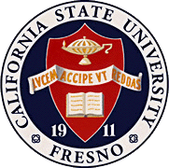
California
State
University,
Fresno
____

James Mullooly (Chair) - COSS
Florence Cassel Sharma - JCAST
Va Nee L. Van Vleck - CSB
Oscar Vega - CSM
Nagy Bengiamin - LCE
Tiewei Liu - HML
Xuanning Fu - Ex-Officio
Annette Gallegos - ASI

Academic Policy & Planning Committee

Academic Senate
Henry Madden Library 3206
5200 North Barton Avenue M/S ML34
Fresno, CA 93740-8014

P 559.278.2743
F 559.278.5745

_{M E M O R A N D U M}

April 17, 2017

MEMORANDUM
TO: Kevin Ayotte, Chair
Academic Senate
FROM: James Mullooly, Chair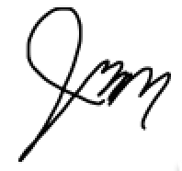
Academic Policy & Planning Committee

RE: APM206 (Technology Mediated Instruction)

This memorandum will serve to inform the Academic Senate that the Academic Policy & Planning Committee moved to approve your consideration of the following modifications to APM 206 at our 4/6/17 meeting.
MSC- To forward the current draft of AMP206 to the Senate for its consideration.

Attached: APM206markup(4-6-17).docx

KEC:vb

