California
State
University,
Fresno
____

Academic Senate
Henry Madden Library 3206
5200 North Barton Avenue M/S ML34
Fresno, CA 93740-8014

P 559.278.2743
F 559.278.5745

_{M E M O R A N D U M}

MEMORANDUM

DATE: September 15 2021

TO: Dr. Saúl Jiménez-Sandoval
President

Dr. Xuanning Fu
Interim Provost

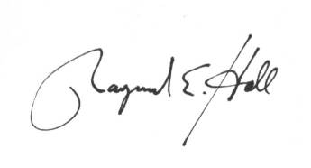
FROM: Dr. Raymond Hall
Chair, Academic Senate

RE: Authorization for flexible interpretation of APM 206

By a vote at the September 13 meeting, the Academic Senate has authorized flexible interpretation of APM 206 specific sections II A and III B to extend through the spring semester of 2022. Flexible interpretation is provided in recognition that currently California, along with the rest of the US, is still operating under restrictions to mitigate the pandemic. Given the uncertainty that we cannot yet know when this pandemic crisis will be over, the Senate extends the ability to offer courses in the so called "virtual mode" we are all now familiar with, if conditions warrant. Virtual mode may be authorized for cases where either the faculty, or members of the faculty’s household, would be put at undue risk from a potential COVID exposure.
This authorization will expire at the end of the Spring 2022 semester.

