EDUCATIONAL OPPORTUNITY PROGRAM
2015 SUMMER BRIDGE PROGRAM
Counselor Internship Application

Position: ACADEMIC COUNSELOR INTERN

Program Description: The Summer Bridge Program is a three-week orientation and academic experience for first-time freshmen. The program is designed to facilitate the personal, social, and academic adjustment of first-time freshmen to the university.

Job Description: Open to graduate level students. Under the supervision of the Counselor Intern Coordinator, interns will facilitate student orientation and Student Development workshops. Interns will work with other professional staff to assist students with transition to the university, academic advising, and personal counseling. Interns will assist new incoming students in completing all Summer Bridge Program requirements including Early Start, class assignments, fall class schedule, housing arrangements, and assist with information to complete the financial aid process.

Duties Include:
- Manage a caseload of assigned students
- Provide academic advising and personal counseling
- Facilitate weekly Student Development Workshops
- Meet regularly with assigned students and document student contacts
- Meet weekly with the “Academy Team” (instructors, tutors, counselors, and peer mentors)
- Provide intervention strategies, support and adjustment techniques to incoming freshmen students.
- Attend staff training sessions and scheduled meetings
- Attend weekly intern training throughout program
- Participate in scheduled program activities

Minimum Qualifications:
- Must be enrolled in a graduate counseling program at California State University, Fresno or an accredited university and have met the prerequisites for field placement or independent study
- Must have a basic knowledge of campus resources, university policies and procedures
- Have a desire to work with college students from diverse ethnic, cultural, and socioeconomic backgrounds
- Completion of a counseling practicum course (counseling 208) or equivalent
- Must be available on the following dates:
Training dates (tentative): June 22-July 01, 2015
Program dates: July 06-July 24, 2015

Compensation:
- Placement in Summer Bridge may satisfy field placement hours for the counseling program

Submit the attached Application and Resumé to Dennis Padilla; 5150 N. Maple Ave. M/S JA 62 (Joyal Administration Bld, Room 224); Fresno, CA 93740-8026.

Inquiries: Contact Dennis Padilla at (559) 278- 5356 or email application to djpadilla@csufresno.edu

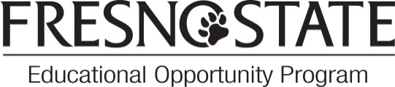
Application Deadline: Friday, April 10, 2015 or until filled

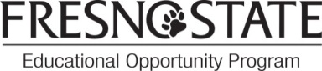
Summer Bridge Counselor Intern Application

Personal Information_______________________________________________________

Last Name: | First Name:
Student ID: | Phone:
Gender: (optional) Male Female | Fresno State Email:
Address: | City, State, Zip:
Emergency Contact Person: | Emergency Contact Person Phone:

Academic/Career Information_________________________________________________________

Undergraduate degree: | College/University:
Graduate units completed: | Graduate program (w/option):

Have you completed the counseling practicum (Coun. 208) or similar course? Yes No

If not, will the practicum be completed prior to the start of Summer Bridge? Yes No
Are you interested in completing field placement hours in Summer Bridge? Yes No
Other than the field placement class, do you plan to enroll in summer classes?
Yes No
Do you plan to work another job during Summer Bridge?
Yes No
Do you have special skills or experiences?

Briefly, what do you hope to learn from this internship?

References (2 minimum) ___________________________________________________

Name | Title/relationship | Phone Number

I certify that all information submitted on this application and my resume is truthful and accurate to the best of my knowledge and that references listed on this application may be contacted.

Date: | Signature

*****NOTE: Please submit application and resume together ********
Illegible completion of form will not be considered for interviews

